
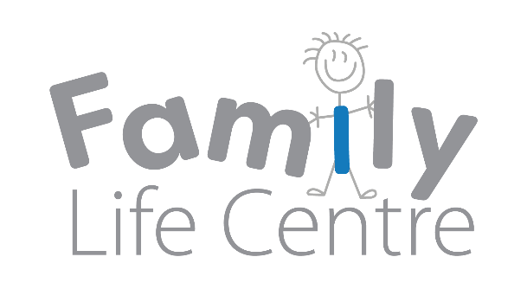
Children and Families Forum
03/05/2018
Family Life Centre, Stirling
Present | Natalie Masterson- SVE (Chair)  Rachel Johnston- SVE  Kathleen Forbes– Family Life Centre  Ilona Broatch- Stirling Carers Centre  May Chamberlain- Relationship Scotland  Liza Miles- Family Mediation Central Scotland  Cheryl Hillis- Functional Family Therapy team  Lisa McGloin- Stirling and District Women’s Aid  Maggie McAlpine- Central Advocacy Partners  Andy Williams- Central Advocacy Partners  Christine Macleod- Functional Family Therapy team  Roxanna Milne– SVE (Minutes)
Apologies | There were apologies from John Brown- Volunteering Matters; Lisa Holland- Stirling Council; Fern Milne- Stirling Council; Ann- Marie O’Hare- Ace Cornton; Rachel Keenan- Home Start Stirling and Janine Ryan- Child Minding Services.
Introductions and approval of previous minutes | Natalie began by welcoming all and everyone introduced themselves. Minutes of the previous forum were approved.
Carers Scotland Act 2016- Ilona Broatch, Stirling Carers Centre | Ilona Broatch delivered a presentation outlining the arrangement for the Carers Scotland Act in Stirling, and the current progress of the Act since it went live on the 1 April.  Stirling Carers Centre would encourage any organisations working with Carers to discuss with the individual the importance of assessment and developing a plan. Carers can contact Stirling Carers to arrange for a Carers Plan to be assessed.
Central Advocacy Partners- Maggie McAlpine and Andy Williams | Andy Williams from Central Advocacy Partners outlined the work of the organisation which offers support and advocacy services to parents with learning disability.  Maggie McAlpine described a new project offered by Central Advocacy Partners which specifically works with people with a learning difficultly who are survivors of domestic violence.
Best Start Grant Consultation | Natalie produced a briefing paper on the consultation. The best start grant has a number of new benefits which will be available from the summer of 2019. It will replace the Fair Start Maternity grant  Please send your comments on the grant consultation to Natalie who can compile a response on behalf of the Children and Families forum.
Forum member updates- Rachel Johnston, SVE | Rachel gave an update on the Children’s Strategic Planning group which she attended on the 17th of April. Discussions included  - children services plan report  - pupil equity funding  - holiday hunger programme is being piloted.  Education Scotland funded for mental health training. Action: Third Sector examples of progress on the Children’s Services Plan are welcomed and should be with Rachel by 11 May.
Forum member updates- Cheryl Hillis, Functional Family Therapy team, Action for Children | Forum members updated the forum on progress and achievement in their organisation.  Action: Invite Functional Family Therapy project to present at a future forum.
AOCB | As it is the year of the young person, the Smith Art Gallery and Museum will be displaying art work by young carers in the café. This will begin on Tuesday until the 30th of June.
Date of next meeting | 9th August 2018, 10-12 noon at the Family Life Centre
Minutes prepared 3/5/18 by Roxanna Milne

