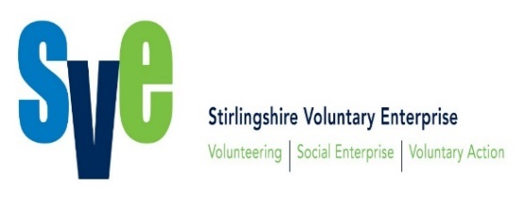

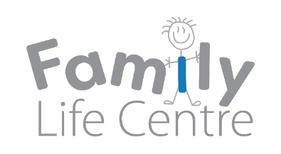

**Children and Families Forum  
28th November 2018 – 10am to 12pm  
Mayfield Centre, Stirling**

|  |  |  |
| --- | --- | --- |
| **AGENDA** |  | **Action** |
| **Present** | Anita Lenyk-Circle, Aileen Duff-Circle, Neil Orr-Children in Scotland, Jennifer Ferguson-Families Outside, Alice Wadkin-SVE, Angela Barron-Recyke-a-Bike, Lillian Campbell-PLUS, Brigid Hanes-COSC, Tony Philips-Coach my Sport, Tony Oneill-Streetgame, Ann Finlayson-Cambusbarron Community Council, Helena Redman-Sistema Scotland, Lynda Perkins-Stirling Council, Jennifer Abernethy-Stirling Council, Frances -Stirling Council, Lisa McGloin –Women’s Aid, Janice Paterson – Cambusbarron Community Council, Aileen McMechin– Education Health and Wellbeing, Tracy Degan-Stirling Council Champions Board, Peter Marrioti-NHS, Sarah Reid-Cats Protections, Saskia – The Conservation Volunteers TCV, Rhonda Archibald- NHS FV Nutrition and Dietician Health Improvement Team, Rachel Johnston-SVE, Tracey Nicholson-SVE, |  |
| **Apologies** | Rachel Keenan – Homestart Stirling  May Kirkwood - Stirling Carers  James Mackenzie – Stirling Council  Janice Beaton – Support for Families |  |
| **Welcome and Apologies** | Rachel Johnston, SVE, welcomed everyone to the Children and Families Forum and asked those present to introduce themselves.  Rachel passed the apologies onto Tracey Nicholson SVE |  |
| **Minutes of last meeting and approval** | 13th September – Minutes approved.  Matters arising – Rachel spoke about the photo call that will take place in jubilee house for the European Volunteer Capital 2018. This photo call will be to announce the winner for the 2020 European Volunteering City. | Rachel to circulate dates |
| **Families Outside** | Jennifer Ferguson gave an overview about Families Outside. It is a national organisation which provide support for families with loved ones in prison. Families Outside covers Stirling and a small area of Clackmannanshire.  Jennifer finished off by attendees asking questions. | . |
| **New Women’s Outreach Service** | Anita Lenyk and Aileen Duff from Circle – Womens Outreach Service gave an overview of the services they provide for women and families across Clackmannanshire and Stirling. The organisation is very new and only been running for 5 weeks.  Anita is a councillor/Addiction worker providing support for women who have become addicted to substance abuse and is reaching out to any women who haven’t been able to access any support to the existing services.  Aileen spoke about the family support service who work with the family. They offer support and engage in any issues e.g. drugs, mental health, childcare. Based on project Circle, from Lanarkshire.  Information leaflets were on tables in front of attendees.  Aileen and Anita finished off by taking questions from attendees. |  |
| **Holiday Fun Clubs** | Lynda Perkins and Jennifer Abernethy from Stirling Council gave an overview of the Holiday fun club programme. It was piloted Easter 2017 and was a successful pilot and they had gotten great feedback and was originally one off. Lynda gave an overview of how the Holiday Fun Club started. The aim was to help provide children in poverty with a meal without having the attached stigma of poverty. There were various activates going on.  The Holiday Fun Club needs a sustainable approach and Stirling Council were reaching out to the Third Sector Organisations for any interest.  Jennifer and Lynda finished off by taking questions from attendees.  Neil Orr from Children in Scotland was on hand to help with anything questions about the scheme for anyone who was interested. Neil helped set up the Holiday Fun Club in Glasgow and had advice on experience and challenges, and what do people get from it. | Send Rachel more information to circulate |
| **AOCB** | No other competent business |  |
| **Date of next meeting** | To be confirmed |  |