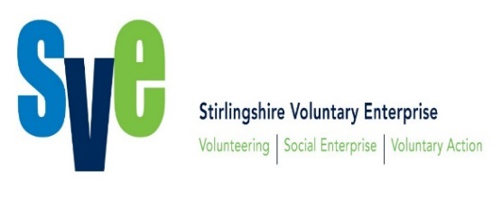

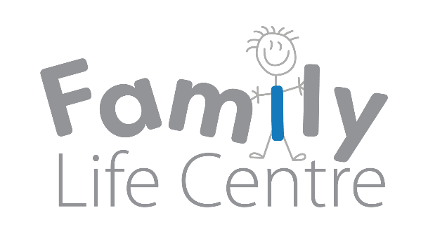

**Children and Families Forum**

**01/02/2018**

**Family Life Centre, Stirling**

|  |  |
| --- | --- |
| **Present** | Polly Rodger- SVE (Chair)  Kathleen Forbes– Family Life Centre  John Brown- Volunteering Matters  Liza Miles- Family Mediation Central Scotland  Lynne Wandrum- Scottish Families affected by alcohol and drugs  Lesley-Anne Livesey- PLUS Sharon Allison- Stirling Interfaith Community Justice group  May Chamberlain- Relationship Scotland  Ilona Broatch- Stirling Carers Centre  Lisa Holland- Skills Youth Employment team  Fern Milne- Skills Youth Employment team  Anna Cook- Stirling and District Women’s aid  Roxanna Milne– SVE (Minutes) |
| **Apologies** | There were apologies from Andy Williams, Margaret Cairney, Anne Salter, Andrea Henderson, Kathleen Frew, Jamie Gillespie, William Brown, Rachel Keenan and Anne- Marie O’Hare. |
| **Introductions and approval of previous minutes** | Minutes of the previous forum were approved. |
| **Year of the Young People 2018- Fern Milne and Lisa Holland** | Fern works with young ambassadors of which there are 10 in the Stirling area. The young ambassadors will be promoting the year of Young People. They will be having their first meeting next Wednesday. Ambassadors will attend events within the community which they will get involved in. They will also take pictures and do reflections on the event. Two of the ambassadors are at school, six are teachers, one is at College and one is in full time work. They will be building links with the University. Clackmannanshire have ambassadors too.  Lisa will coordinate the Year of the Young people plan on behalf of Stirling. They will run key events throughout the year. There is a website for the year of the young people. You can also follow it on twitter via “#yearyoungpeople” and on facebook. The panel of ambassadors will identify a young person every month to be the young person of the month.  This is a great opportunity to enhance social connectedness.  ACTION: Can organisations provide information about any events they have for young people using the pro forma, by the 13th of February.  Lisa will also put the events on the events calendar which will show the vast number of opportunities available. If you would like a Young Ambassador to attend your event please get in touch with Lisa ([hollandl@stirling.gov.uk](mailto:hollandl@stirling.gov.uk)). |
| **Liza Miles- Family Mediation Central Scotland** | Liza trained as a mediator and her role is in community education and fundraising. Family Mediation Central Scotland receive referrals from a wide range of families to provide services across a broad sector. Children go to play at the family contact centre and this is an opportunity for the child to meet with a family member who they may not see very often due to various reasons such as a court order. The session may be supervised whereby someone is present and taking notes or supported whereby the organiser is present in the vicinity of the meeting. The report written can be useful for schools and can help the child receive a diagnosis. The child often benefits from seeing the other parent. All intakes are free although there are some charges for some services. The child contact centre is for children aged up to 8 or 9 years and they are always given the choice about meeting a family member. Sometimes family members have suffered from postpartum depression, drug or alcohol abuse. Liza would encourage people to come and talk to Family Mediation Central Scotland and arrange a meeting with family support workers. The centre is keen to have young people volunteering at the centre. |
| **Children’s Services Plan Update** | A new [Children’s Services Plan](https://www.stirling.gov.uk/__documents/education-and-learning/policies-and-guidelines/childrens-services-plan/childrensservicesplan.pdf) for Stirling has been agreed and is for all of Stirling’s children and young people (up to the age of 18 years and care leavers up to the age of 25) and their families, and all staff working in agencies in the Stirling area who provide:   * services directly to children, young people and families, or; * related services that could have a significant effect on the wellbeing of children and young people.   The three priority areas are children in low income families, mental health and care experienced. To view the full document, click here <https://www.stirling.gov.uk/__documents/education-and-learning/policies-and-guidelines/childrens-services-plan/childrensservicesplan.pdf>  Stirling will establish a Champions Board to lead this area. They received funding from life changes trust to assist them. Two workers will be employed and the project will be funded for three years. The theme of the year one plan will include participation, establishment of the champions board, leadership, sustainability and learning and development. They have a detailed plan for three years.  A previous group has expanded to lead on the area of mental health. In its current form it has met twice with the third meeting in February. They have been working closely with a group of young people who co- designed the mental health event late in 2017 with a follow up scheduled for March.  For children in low income families a draft plan has been prepared. Outcomes include reducing hunger and increasing food skills, cost of the school day and income maximisation.  Refer to the children services plan document. Please provide your response to the document by email to Polly Rodger ([pollyrodger@sventerprise.org.uk](mailto:pollyrodger@sventerprise.org.uk)). |
| **Communication and engagement with Children, Young people and parents** | Please refer to the Stirling Children’s Services plan 2017- 2020. Feedback from families would be helpful. |
| **Workforce development discussion 2018-19** | The group identified that they were interested in GDPR training. A workshop will take place at the Forth Valley Third Sector Conference on the 13th of February on this topic.  Ilona Broatch (Stirling Carers Centre) said that the Carers act is coming out in April. Training is available to anyone working with carers.  Sharon Allison (Stirling Interfaith Community Justice group) said that the Hidden Sentence training will be delivered at Cornton Vale. It will look at the impact of imprisonment on families. Sharon will be working with Barnardos and will be delivering train the trainer training on Child Sexual Exploitation.  Scottish Families affected by alcohol and drugs said that they are running Craft training on community reinforcement which will be used with family members. It will use the method of cognitive behavioural therapy. She said she would like this promoted via the e-bulletin.  PLUS are running training on inclusion and disability awareness, autism and communication.  Stirling and District women’s aid are providing training on domestic abuse. If you are interested then please email Jessica (Jessica@stirlingwomensaid.co.uk). |
| **AOCB** | Kathleen Forbes is now a qualified family practitioner. She will be taking referrals. Although please note that this is not family support.  John Brown said that Volunteering Matters is launching their new befriending project in Clackmannanshire after two years of work. They are going to be funded for three years. He is looking forward to getting started. He is accepting referrals from schools and social work for children who are isolated. He needs role models who would be able to meet every two weeks with the child to provide respite to families. The aim is to boost the social skills and confidence of the child. |
| **Date of next meeting** | 3rd May 2018, 10-12 noon at the Family Life Centre |

Minutes prepared 1/2/18 by Roxanna Milne